**Local Server Walkthrough** (Project Group 6)

1. **Download and Install Apache HTTP Server:**
   1. 
   2. **Once on the web page click on Download! underneath Essentials and from there click on a a number of third party vendors for Windows:**
      1. 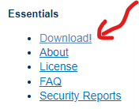
      2. 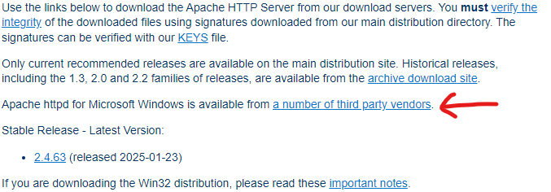
2. **Once on the next webpage, click on Apache Lounge and download Apache 2.4.63-250207 Win64 zip file:**
   1. 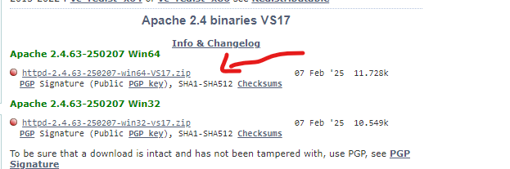
3. **Once the file is downloaded, unzip it and save it somewhere that is easy to remember (i.e. Desktop or a New Folder):**
   1. 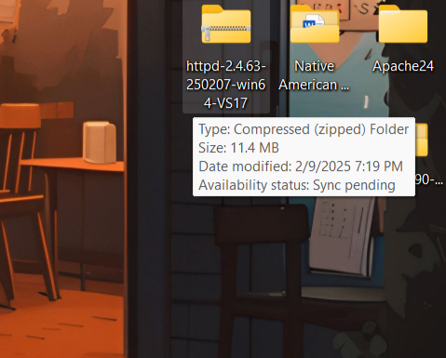
   2. 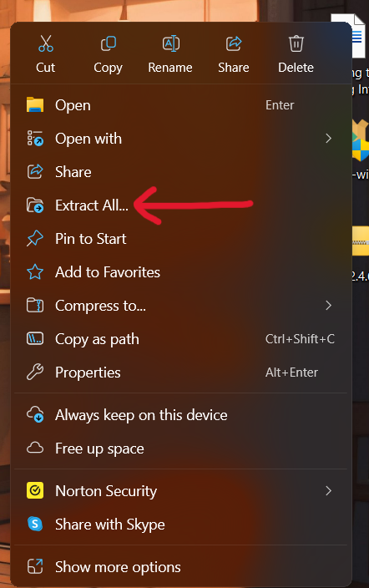
4. **Once the file has been unzipped, go to the Apache24 folder and once inside, click on the bin file:**
   1. 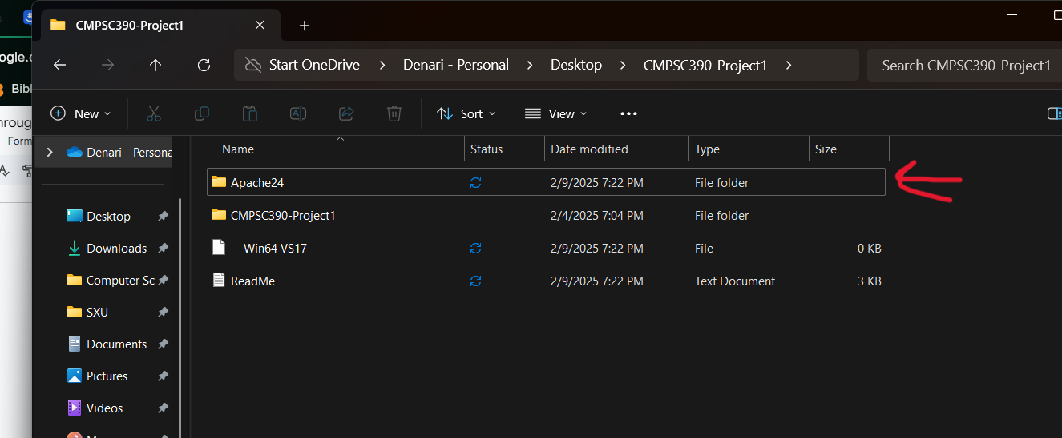
   2. 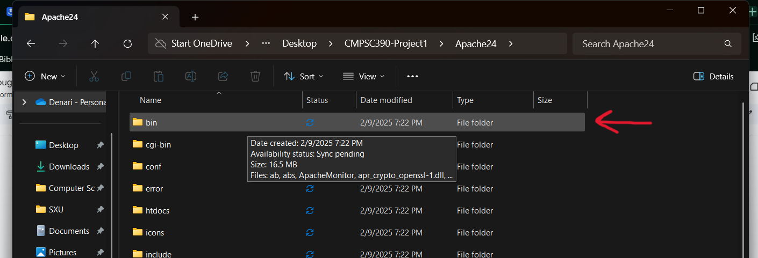
5. **Inside of the bin folder you will see an application called “httpd” which you will install via Command Prompt on your computer.**
   1. 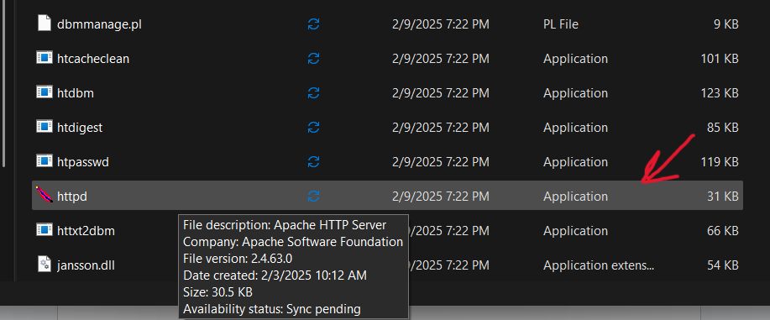
   2. 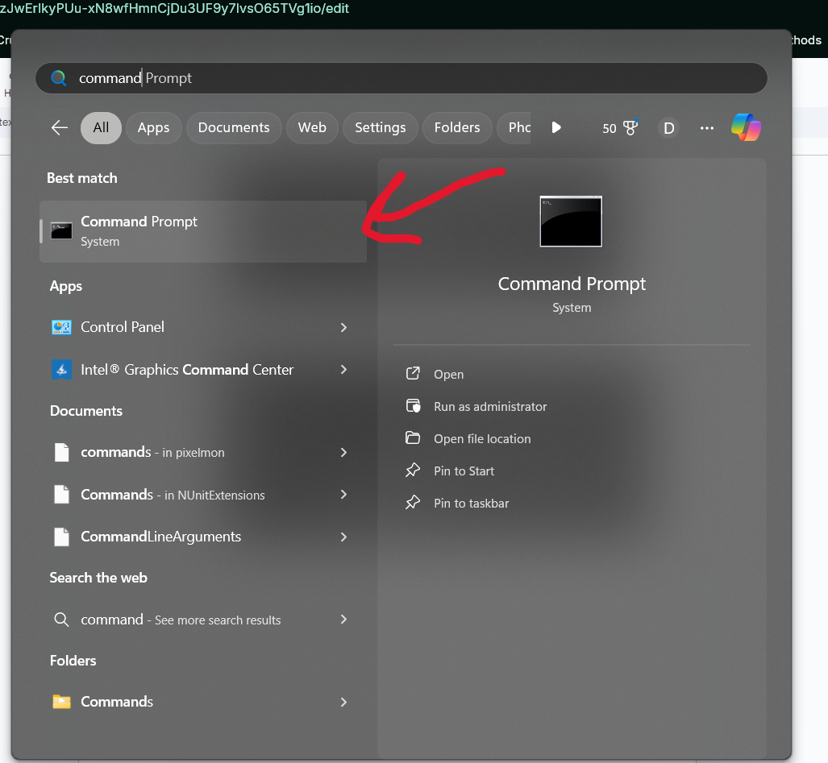 
      1. **When running Command Prompt, be sure to open as administrator.**
6. **Once the command prompt is opened, copy and paste the directory of Apache24\bin**
   1. 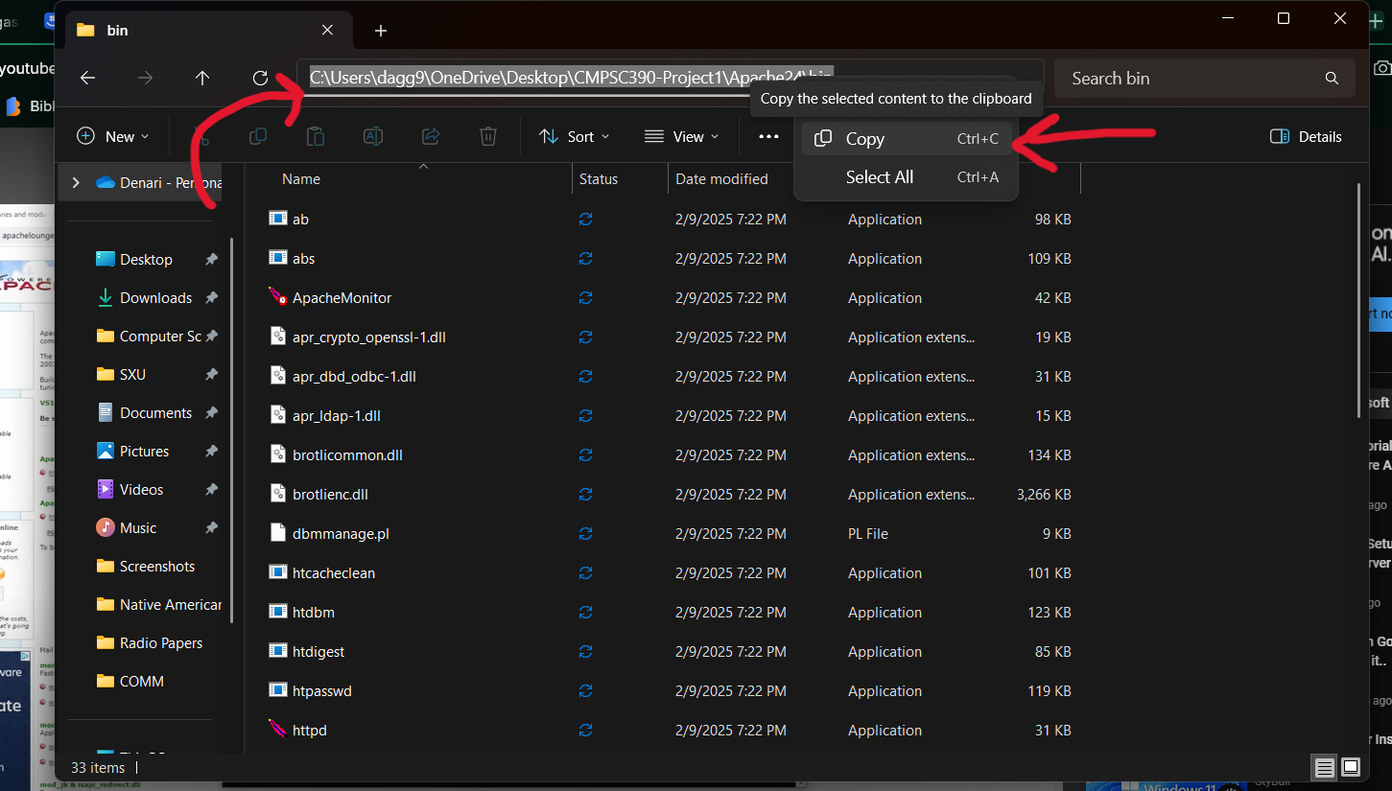
7. **Inside of the command prompt, type “cd” and the name of the copied directory.**
   1. 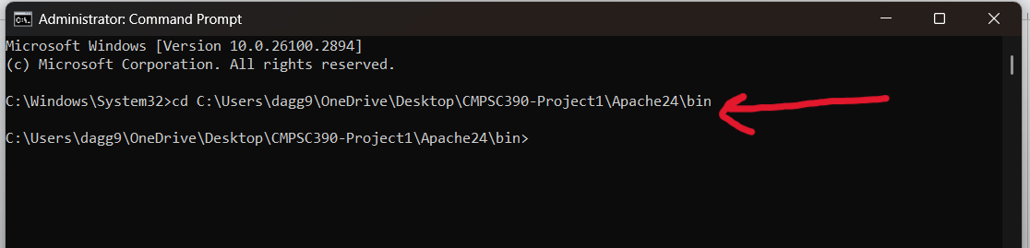
8. **Once inside the directory, type “httpd -k install” to install the service onto your computer:**
   1. 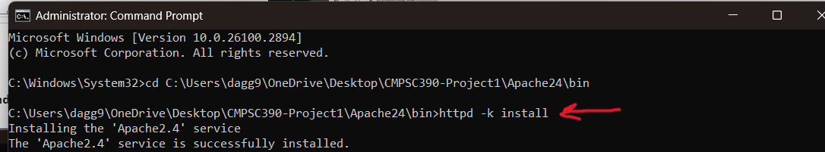
      1. **If prompted to allow access by Windows Defender Firewall, just click on “Allow Access”.**
      2. **To check if the services were installed, type “services” into the windows search bar and click on it to see if the service has been installed.**
         1. 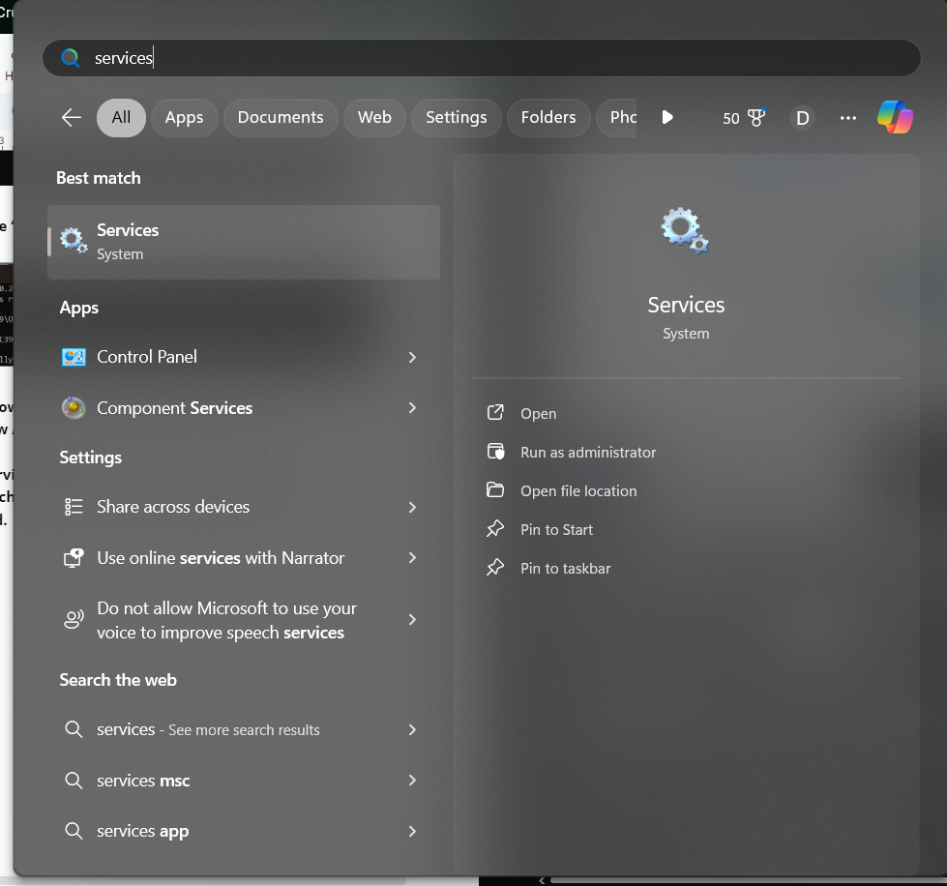
         2. 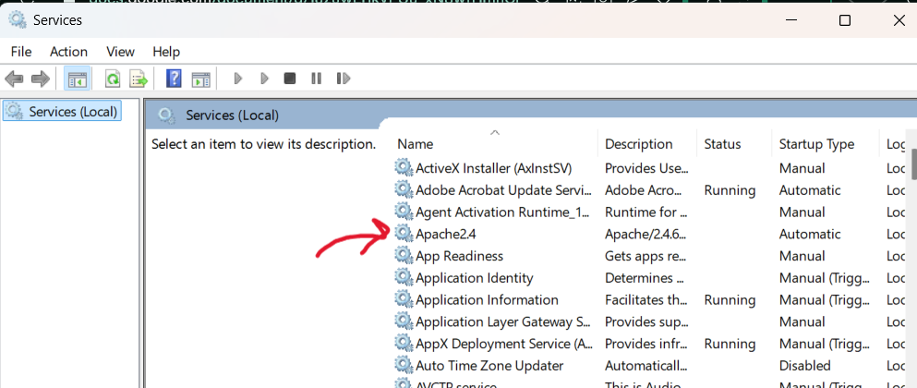
9. **On the service page, click on Apache24 and set its status to running by starting the service:**
   1. 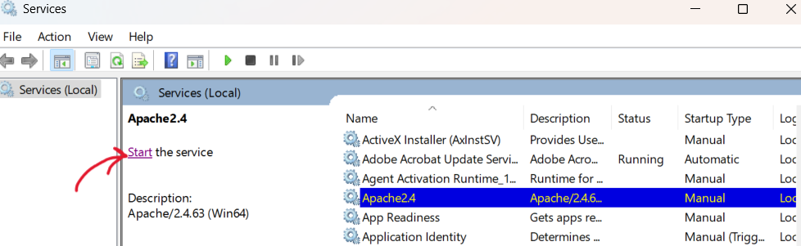
      1. **To ensure that the service is running, the status of Apache24 should be “Running”.**
10. **To check whether the service is running or not, go to the web address bar and type “127.0.0.1” which should display a screen saying “It works!”**
    1. 
11. **Once everything is running perfectly, you can go back to the Apache24 file and access the index where you would be able to code and create the webpage:**
    1. 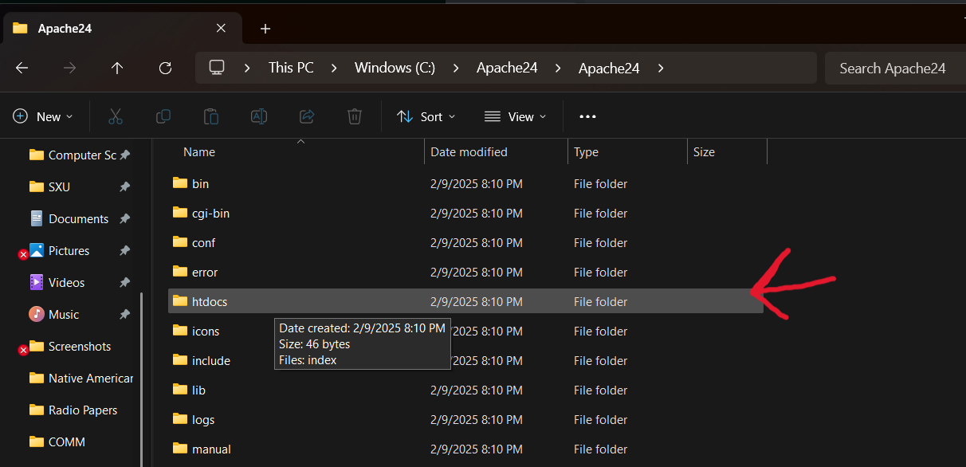
    2. 